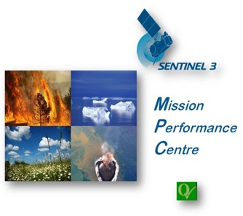

Technical Note on
Sentinel-3
Performance over
Land Ice

Document Ref.:
Date: | 20/10/2021
Issue: | 1.0
Author(s): | A.Muir (MSSL), D.Brockley (MSSL), M.McMillan (Univ. of Lancaster), S.Baker (MSSL), J.Gaudelli (MSSL)
Approved by: |  | Authorized by | J. Bruniquel, Service Manager
Distribution: | ESA, S3MPC
Accepted by ESA | P. Féménias, ESA TO
Filename

Copyright ©2019 – CLS, ECMWF, isardSAT, LEGOS, MSSL, NOVELTIS, PML
All rights reserved.
No part of this work may be disclosed to any third party translated, reproduced, copied or disseminated in any form or by any means except as defined in the contract or with the written permission of ACRI-ST

Disclaimer
The work performed in the frame of this contract is carried out with funding by the European Union. The views expressed herein can in no way be taken to reflect the official opinion of either the European Union or the European Space Agency.
 |  | 

Table of Contents
Table of Contents 2
Acronyms 2
Purpose of Document 3
Applicable ESA L2 Product Baseline 3
Measurement Availability and Validity over Land Ice per Band of Slope 3
Spatial Coverage of Measurement Failure 4
Measurement Precision 6
Validation of Measurement Accuracy 12
Known Issues over Land Ice 14
References 14

Acronyms

ATM | Airborne Topographic Mapper
CS2 | CryoSat-2 satellite
DEM | Digital Elevation Model
ESA | European Space Agency
IPF | Instrument Processing Facility
L1B | Level-1B product or processing. L1B data is the Level-0 (raw) data corrected for instrumental and geometrical effects.
L2 | Level-2 product or processing. L2 is the Level-1 data corrected for geophysical effects.
LRM | Low Resolution Mode
MAD | Median Absolute Deviation
PB | Product Baseline
POCA | Point Of Closest Approach
OCOG | Offset Centre of Gravity (retracker)
OLTC | Open Loop Tracking Command
S3 | Sentinel-3 missions
S3A | Sentinel-3A mission
SAR | Synthetic Aperture Radar
SARin | Synthetic Aperture Radar in Interferometric mode (available on CryoSat-2).
SD | Standard Deviation
SRAL | Sentinel-3 Ku/C Radar Altimeter

Purpose of Document

This technical note provides details of the current performance (measurement coverage, precision, accuracy) of Sentinel-3A and Sentinel-3B missions over land ice surfaces.

The performance is measured from the latest ESA Level-2 operational products and is not necessarily the final or optimal performance of the S3 missions over land ice.

It has been shown by studies (McMillan et al, 2021[R1]) during the tandem phase that Sentinel-3A and Sentinel-3B operate with statistically equivalent accuracy and precision, even over complex terrain and therefore performance results in this document are not repeated for both missions unless specifically stated.

Applicable ESA L2 Product Baseline

In this technical note the performance is measured with ESA Level-2 Land products from the following product baseline:

 | S3A | S3B
Product Baseline | 2.68 | 1.43
Baseline Collection | 004

Note that in 2022 a new ESA Thematic Land Ice L2 product is due for release with improved performance over areas of higher ice sheet slope. This document does not cover the performance obtained with that product.

A previous published study by McMillan et al, 2019 [R3], showed the performance of S3A over Antarctica derived from an equivalent but slightly different (CPOM, UK) L2 processor and ESA L1b product.

Measurement Availability and Validity over Land Ice per Band of Slope
This section shows how successful the S3 radar instrument and ground processing is at returning quality elevation measurements over different ice sheet areas and bands of surface slope. There are two elevation parameters included in S3 L2 Land products : elevation_ocog_20_ku (derived using an OCOG empirical retracker) and elevation_ice_sheet_20_ku (derived using a physical ice sheet model retracker), which each have their own statistics of measurement success or failure.

The primary measurement over land ice is ice surface elevation, which is measured using the Ku-band SAR mode radar instrument at 20Hz along the orbit track. Each measurement location is calculated at the point of closest approach (POCA) of the radar beam using a correction for surface slope derived from an external digital elevation model (DEM). Measurement locations are therefore slope and terrain dependent and are across track and up slope from the nadir location of the satellite.
Elevation measurements are only obtained if the returned radar echo (following SAR processing) is within the range window, and if the shape of the echo can be identified as a being reflected from an ice surface. Over complex terrain or areas of high slope, measurement of elevation is not always possible due to limitations of the radar instrument or due to the capability of the ground processing (which is likely to improve in future product evolutions). The success or failure of attempted elevation measurements are therefore highly correlated with ice sheet surface slope, terrain complexity, and ground processing techniques.

In this section we show the current measurement coverage (% of 20Hz echoes where elevation is successfully measured) over different slope bands of the ice sheet in Antarctica and Greenland for the two different techniques used to measure elevation in the ground processing (OCOG empirical retracking, and ice sheet physical model retracking).
 | Parameter: elevation_ocog_20_ku
Slope band (degrees) |  | Antarctic Ice Sheet |  |  | Greenland Ice Sheet
 |  | % of total  area | % available | %valid | % of total area | % available |  | %valid
All slopes |  | 100% | 96.98% | 88.56% | 100% | 95.86% |  | 83.08%
0 to 0.1° |  | 27.2% | 99.86% | 98.84% | 9.45% | 99.72% |  | 98.66%
0.1 to 0.2° |  | 27.3% | 99.51% | 97.54% | 27.84% | 99.74% |  | 98.81%
0.2 to 0.3° |  | 14.4% | 98.66% | 94.89% | 17.4% | 99.17% |  | 96.34%
0.3 to 0.4° |  | 8.18% | 97.47% | 90.67% | 11.25% | 98.25% |  | 92.34%
0.4 to 0.5° |  | 5.23% | 96.20% | 85.25% | 7.4% | 97.16% |  | 85.60%
> 0.5° |  | 17.58% | 87.28% | 53.68% | 26.63% | 86.90% |  | 47.84%

 | Parameter: elevation_ice_sheet_20_ku
Slope band (degrees) |  | Antarctic Ice Sheet |  |  | Greenland Ice Sheet
 |  | % of total  area | % available | %valid | % of total area | % available |  | %valid
All slopes |  | 100% | 77.00% | 77.00% | 100% | 70.25% |  | 70.25%
0 to 0.1° |  | 27.2% | 95.48% | 95.48% | 9.45% | 96.11% |  | 96.11%
0.1 to 0.2° |  | 27.3% | 90.17% | 90.17% | 27.84% | 95.02% |  | 95.02%
0.2 to 0.3° |  | 14.4% | 79.90% | 79.90% | 17.4% | 83.54% |  | 83.54%
0.3 to 0.4° |  | 8.18% | 68.62% | 68.62% | 11.25% | 70.26% |  | 70.26%
0.4 to 0.5° |  | 5.23% | 60.00% | 60.00% | 7.4% | 58.10% |  | 58.10%
> 0.5° |  | 17.58% | 34.66% | 34.66% | 26.63% | 29.87% |  | 29.87%

% available is the percentage of measurements where an elevation value is returned.
% valid is the percentage of measurements where an elevation value is returned and the Level-2 waveform quality tests are passed.

These statistics indicate that OCOG derived elevation parameter has the highest measurement retrieval rate (88.56% overall over Antarctica), decreasing with surface slope to 53.68%. This is because the OCOG empirical retracker is less sensitive to algorithm failure caused by changes in waveform shape over more complex terrain. In contrast the ice sheet physical model retracker is tuned to fit the shape of classical ice sheet waveforms returned from areas of low slope and will fail when presented with complex or multi-peaked returns which do not fit its model. Note that the elevation_ice_sheet_20_ku parameter always has the waveform quality tests applied and hence statistics of %valid and %available are the same.

Spatial Coverage of Measurement Failure

This section shows the locations where measurement failures and/or poor waveform quality occur over the ice sheets for each elevation parameter. These predominantly correspond to areas of high slope and complex terrain around the ice sheet margins, with the ice sheet physical model derived elevation parameter showing much higher failure rates in these areas.

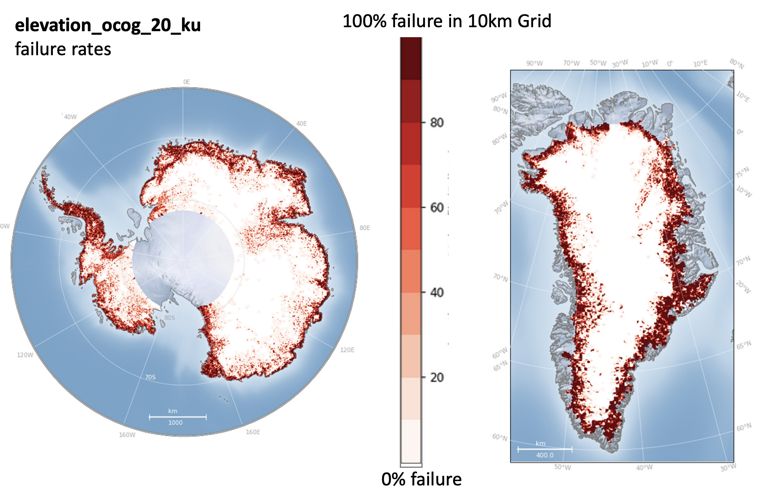

Figure 1: Percentage measurement failure of elevation_ocog_20_ku (gridded at 10km), after filtering for waveform quality

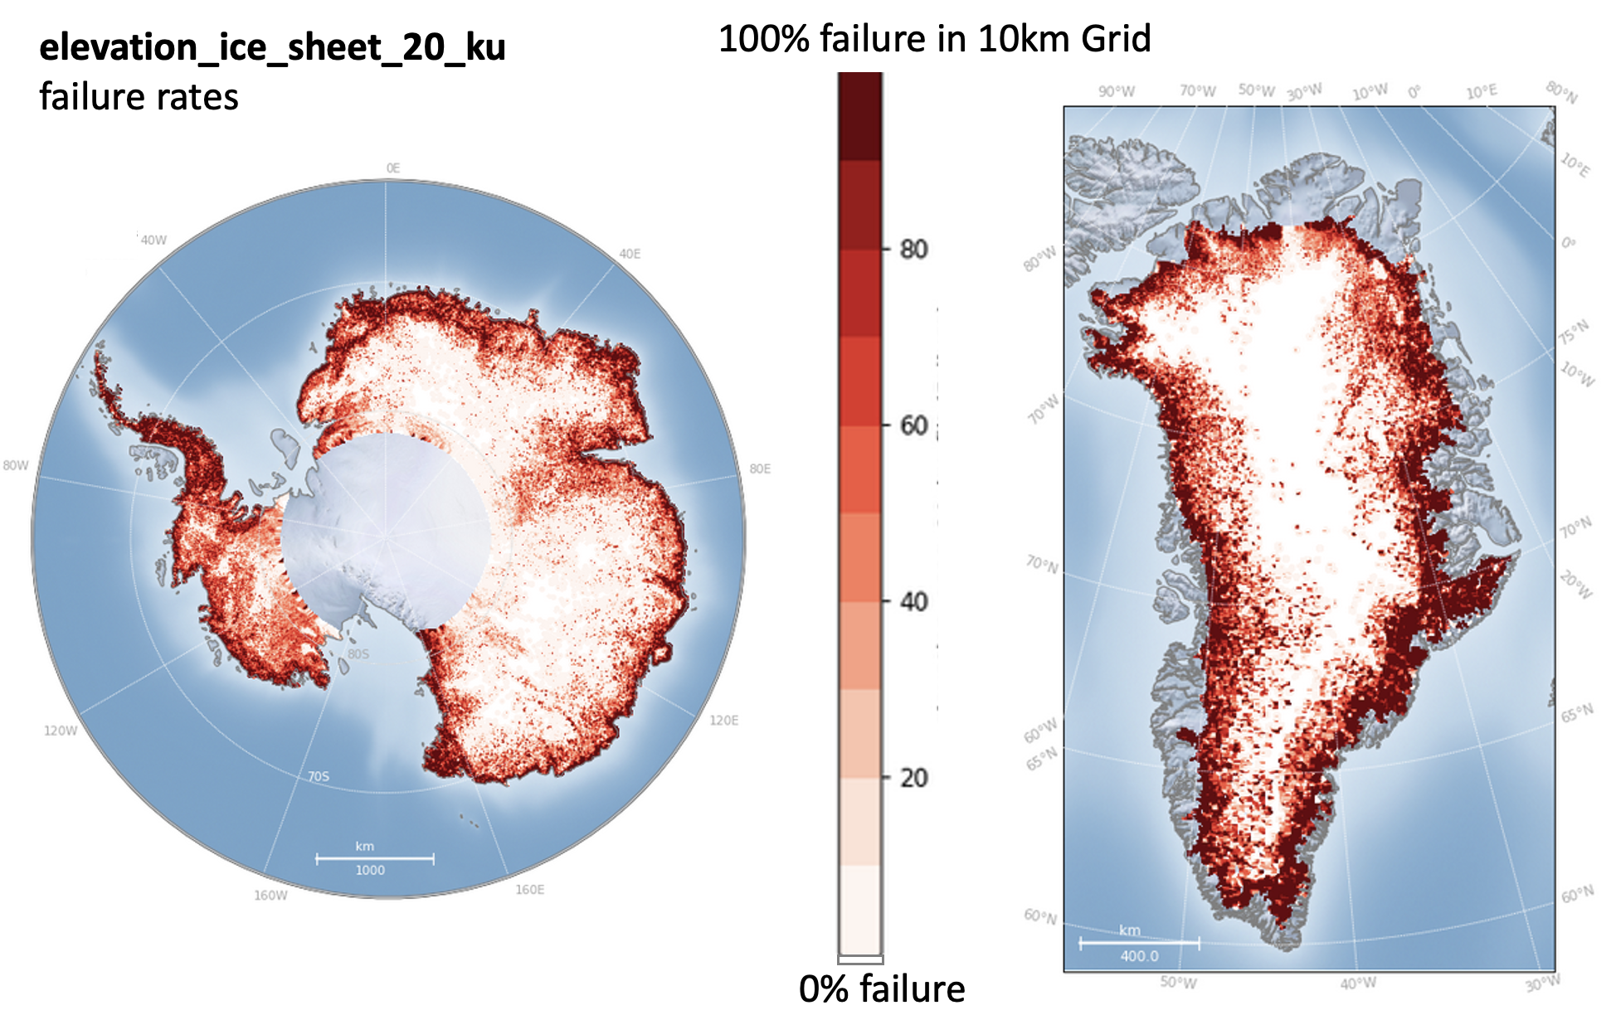
Figure 2: Percentage measurement failure of elevation_ice_sheet_20_ku (gridded at 10km), after filtering for waveform quality

The detailed pattern of measurement failure over a typical area of increasingly high slope and some areas of rough terrain in the Antarctic margins is shown in figure 3 for both elevation parameters.
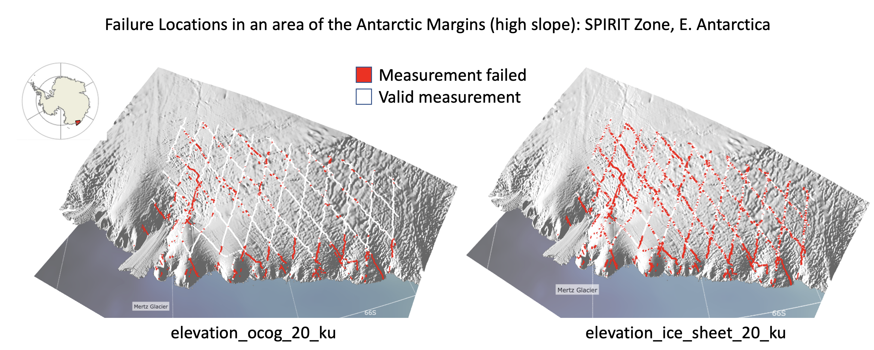
Figure 3: Measurement or waveform quality failure locations in an area of high slope in the Antarctic ice sheet margins (SPIRIT Zone)

Measurement Precision
This section measures how precise the S3 radar instrument and ground processing is at repeating measurements over the same ice sheet locations over short enough period such that the ice surface will normally not have changed significantly.

Here we measure the shot-to-shot precision (repeatability) of elevation measurements from Sentinel-3A over different ice sheet surfaces by calculating the elevation differences at orbit crossover points over a 27-day repeat cycle. Over this short period, we would normally expect minimal physical change in the ice sheet surface and hence any elevation differences found can be attributed to measurement errors and an estimate of achievable accuracy and precision. To measure accuracy and precision over the entire ice sheet surface we use the elevation measured from the OCOG retracker which has the best coverage over all terrain types.

Firstly, we show the statistics and histograms of all single cycle crossover differences for the complete S3A mission (cycles 12-73) over the entire Antarctic and Greenland grounded ice sheets.

 | Antarctic Ice Sheet | Greenland Ice Sheet
Number of crossover differences | 2320075 | 282453
Median difference (m) | 0.00 | -0.001
SD (m) | 0.92 | 1.67
Median Absolute Deviation (m) | 0.31 | 0.43

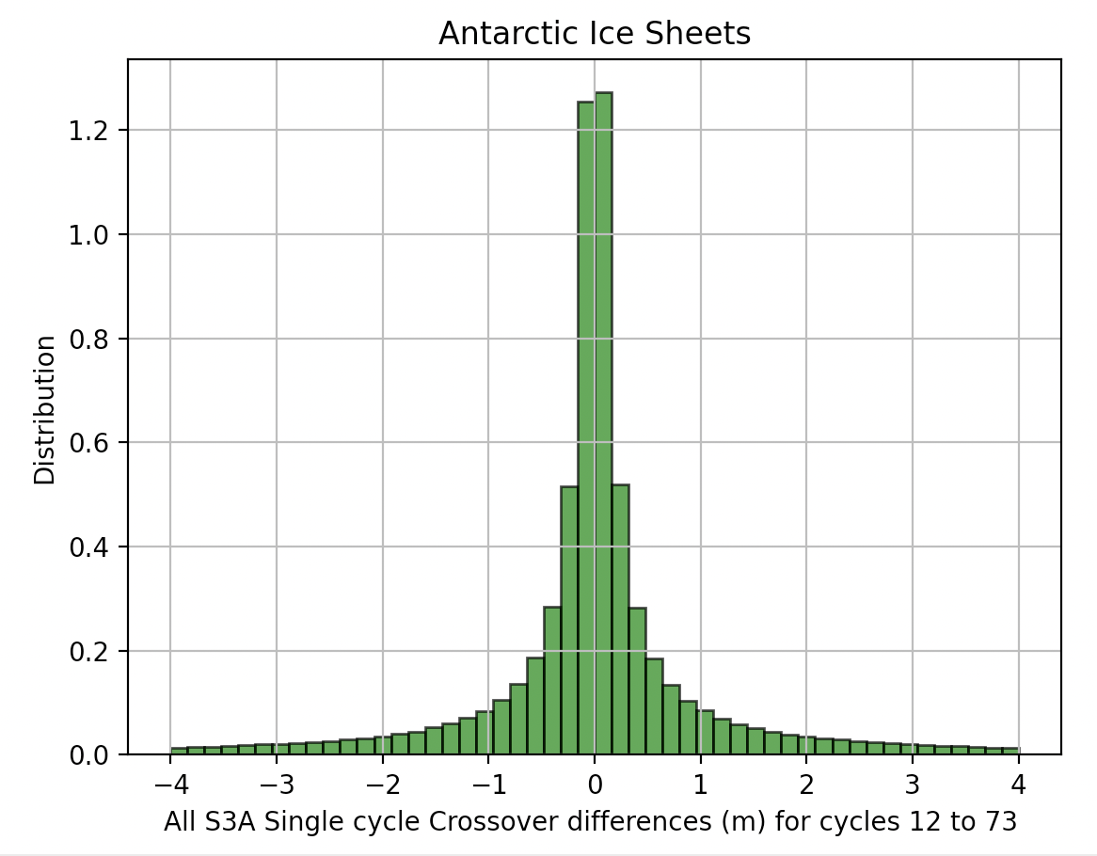

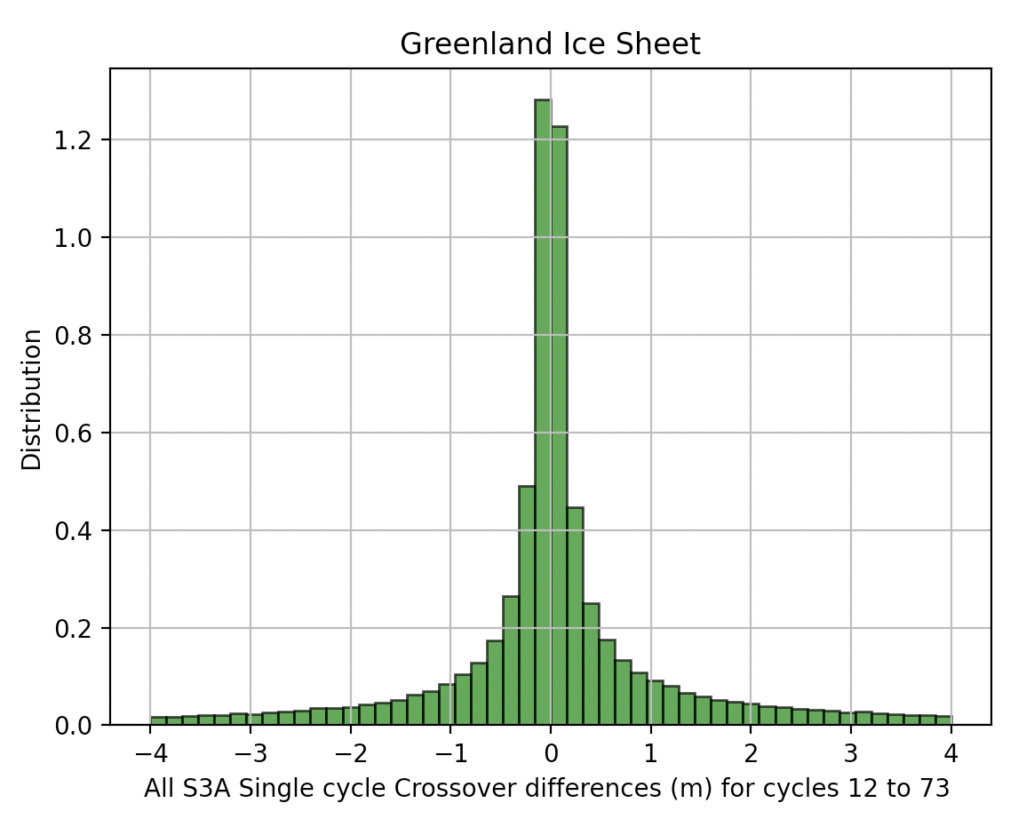
Figure 4: Histogram of S3A Single Cycle Crossovers (all cycles) for a) Antarctic ice sheet, b) Greenland ice sheet

The median difference is < 1cm in both cases and the majority of differences are clustered around the central value reflecting the good repeatability of measurements around the low-slope interior of the ice sheet.

As can be seen from the spatial distribution of crossover differences (figure 5), the magnitude of differences increases with surface slope towards the ice sheet margins.
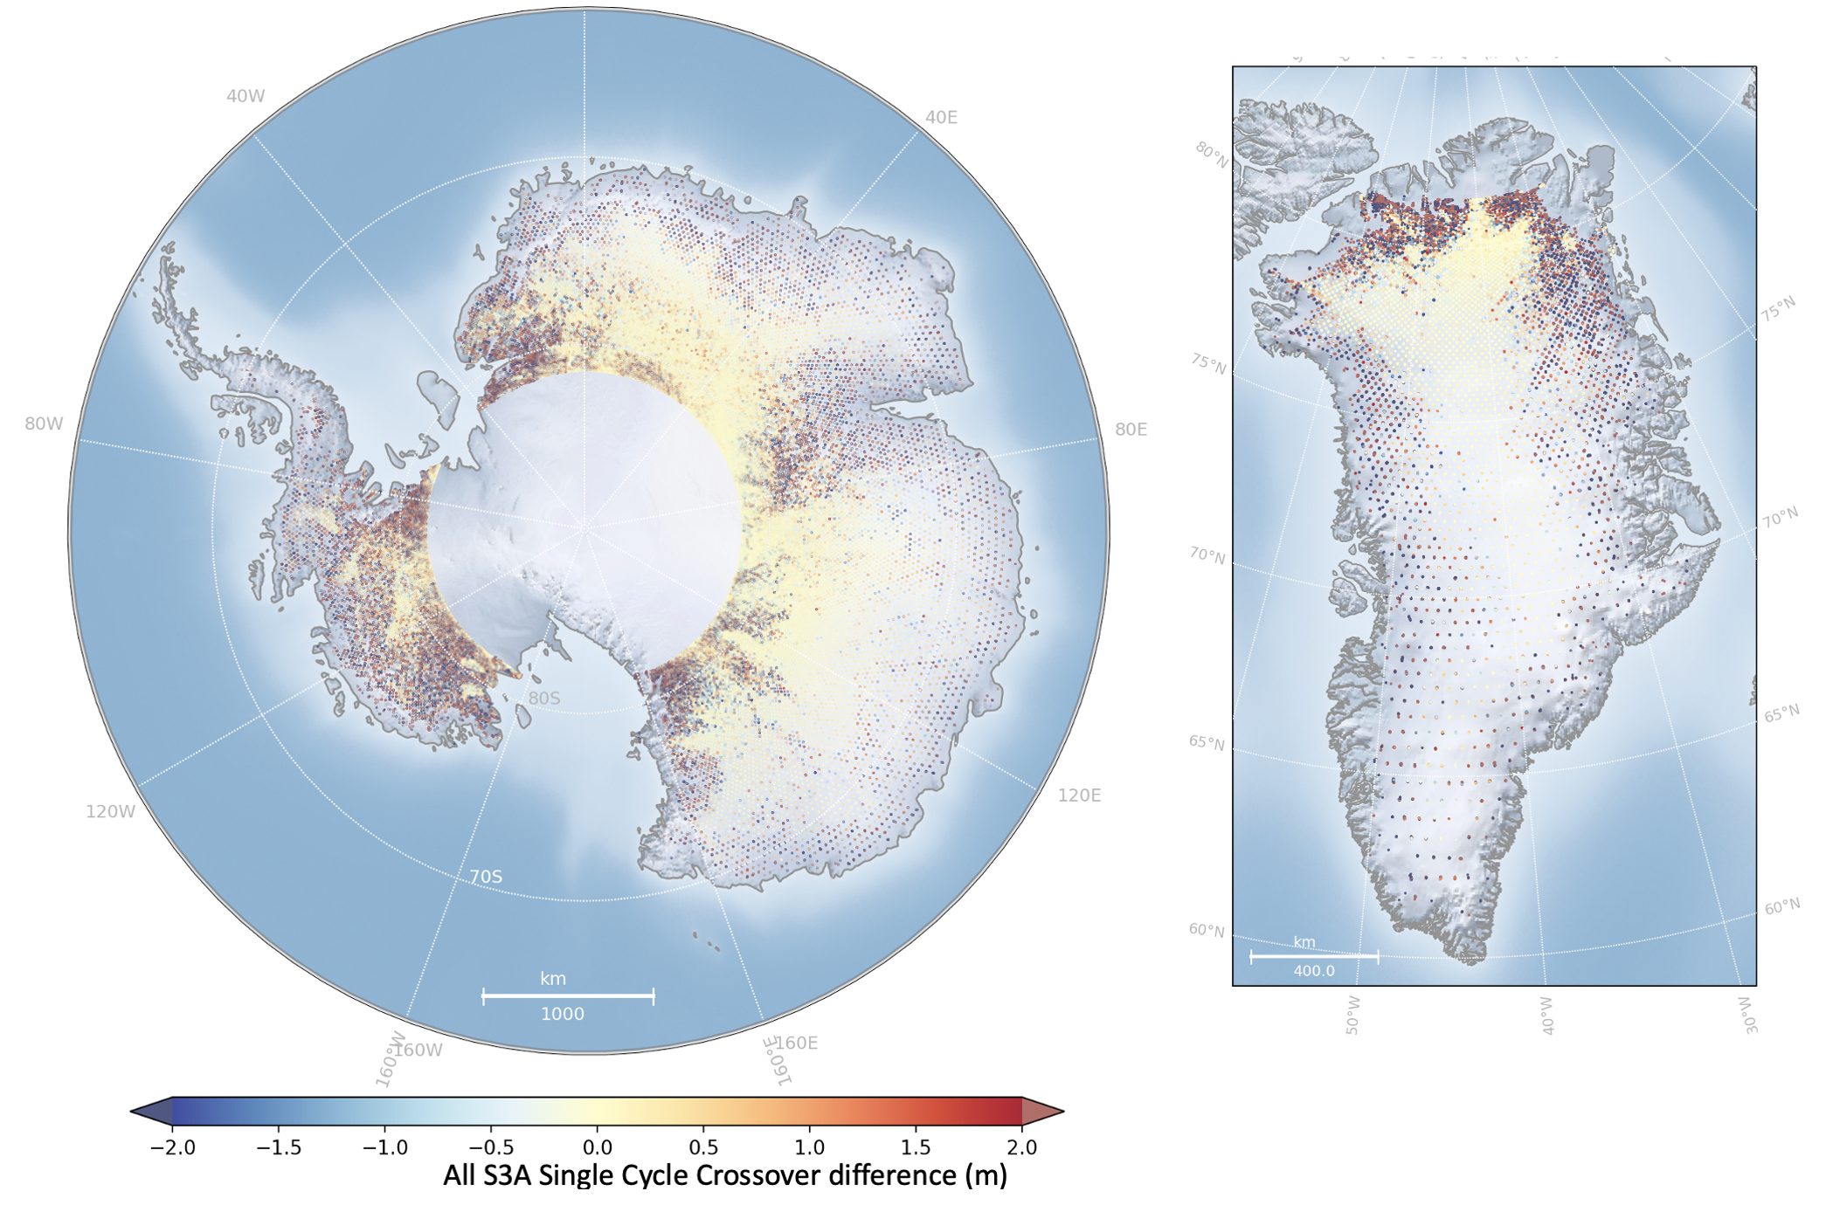
Figure 5: S3A Single Cycle Crossover Differences (from all cycles) over Antarctica (left) and Greenland (right)

We can divide up the crossover differences in to 0.2 degree bands of slope and show the precision achievable in each slope band per cycle (using the median absolute differences, a robust measure of dispersion). Note that the step after cycle 52 is due to the introduction of a new slope model in PB2.61/IPF 6.18 which increases precision.

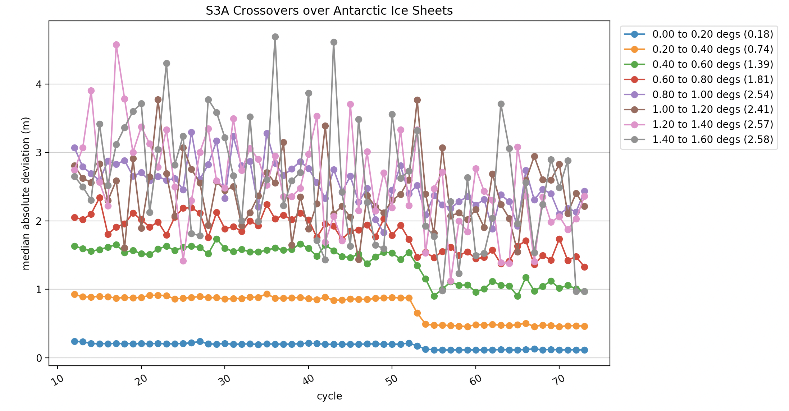
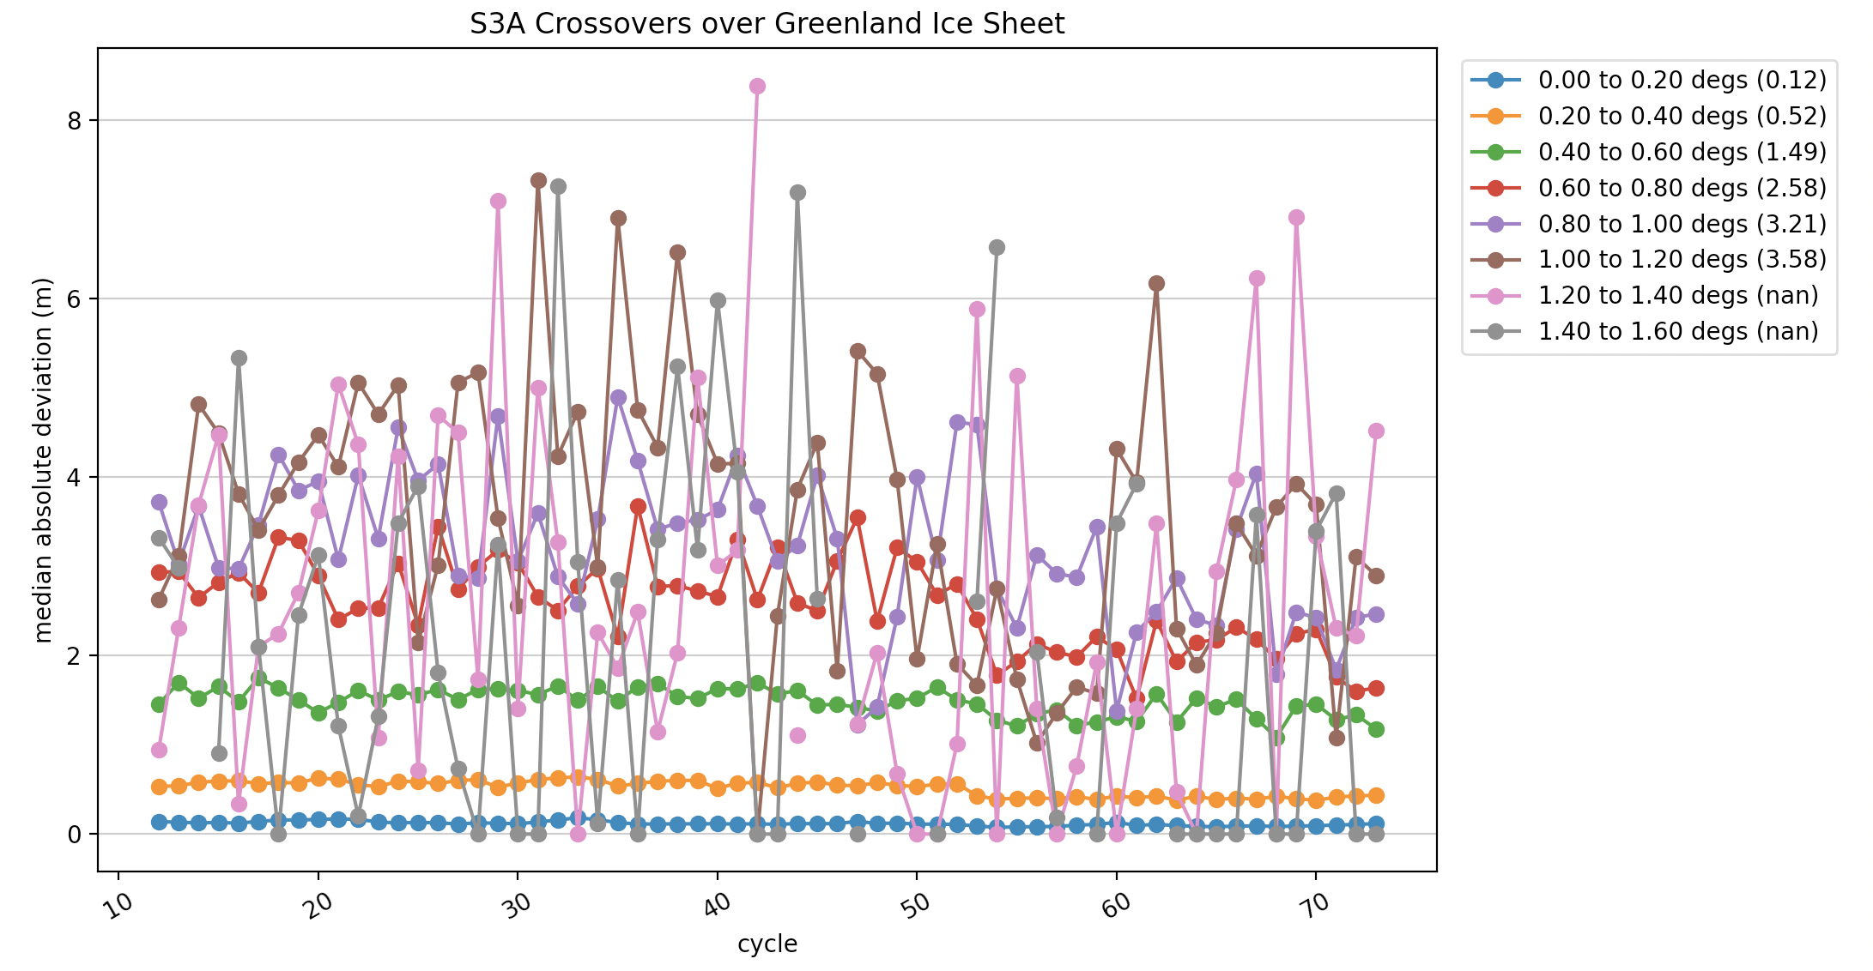
Figure 6: S3A Precision per cycle and per 0.2 degree slope band over (a) Antarctica, b) Greenland. Key numbers in () indicate the mean of the MAD values in the slope band.

The precision achieved by crossovers from the whole S3A mission period per band of slope is shown is figure 7, with comparative data from CryoSat-2 (baseline-D, covering both LRM and SARin mode aquisitions)
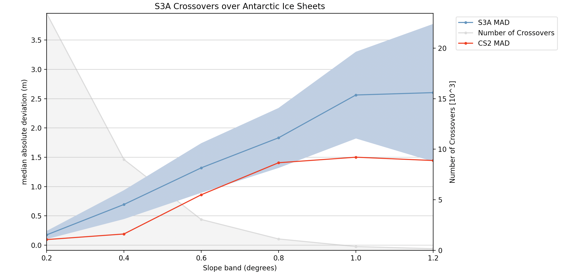

Figure 7: Precision (MAD of elevation differences at crossover) per 0.2 degree slope band from S3A and CS2 over (a) Antarctica, b) Greenland

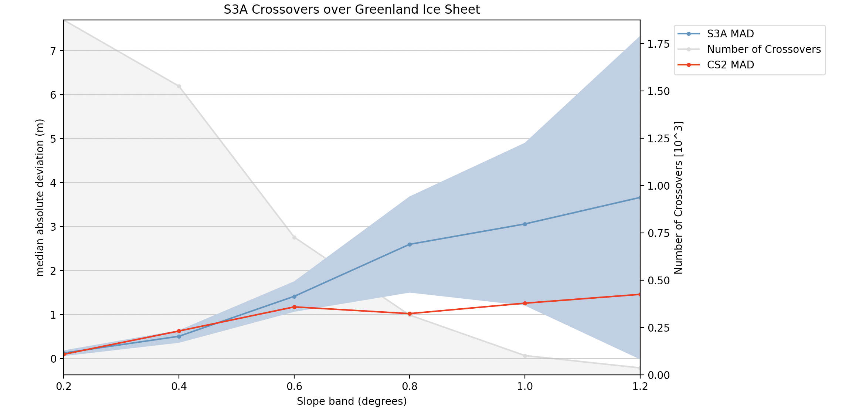
Finally, we measure the maximum precision achievable by S3 over the smooth flat ice sheet surface of Lake Vostok in East Antarctica, often used as a reference surface for radar altimetry. The smooth, flat surface above the lake minimizes the influence of topography and allowed us to focus primarily on the performance of the SRAL instrument itself, and specifically to understand the impact of radar speckle, small-scale variations in the firn backscattering properties and the influence of retracker imprecision on the SAR altimeter measurements
Over this surface S3A has a median crossover difference of 0.0m and precision statistics of 0.05m (MAD), 0.08m (SD)
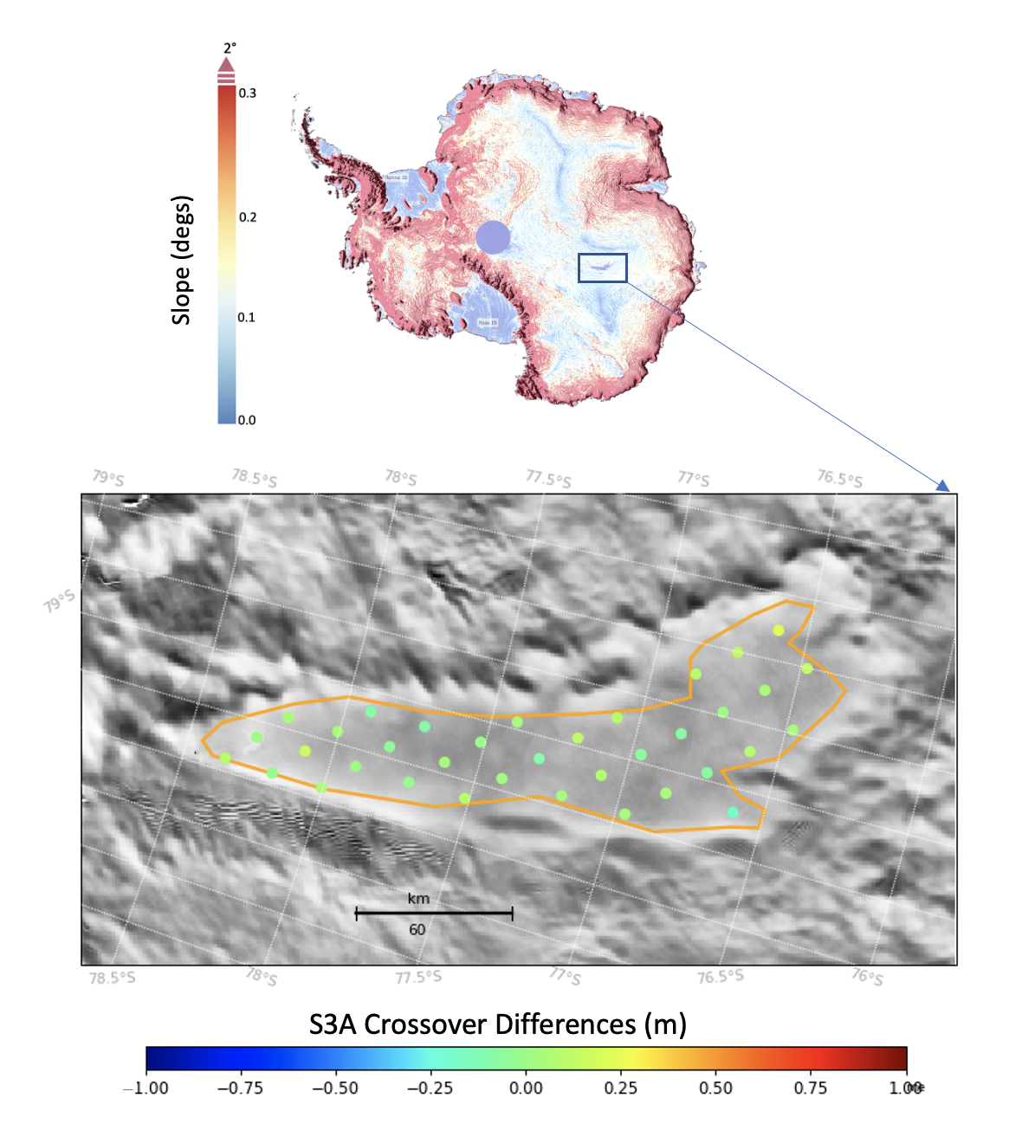
Figure 8: S3A Single Cycle Elevation Differences at Crossover Locations over Lake Vostok:

 | Lake Vostok (centre)
Number of crossover differences  (from all cycles) | 2243
Median difference (m) | 0.00
SD (m) | 0.08
Median Absolute Deviation (m) | 0.05

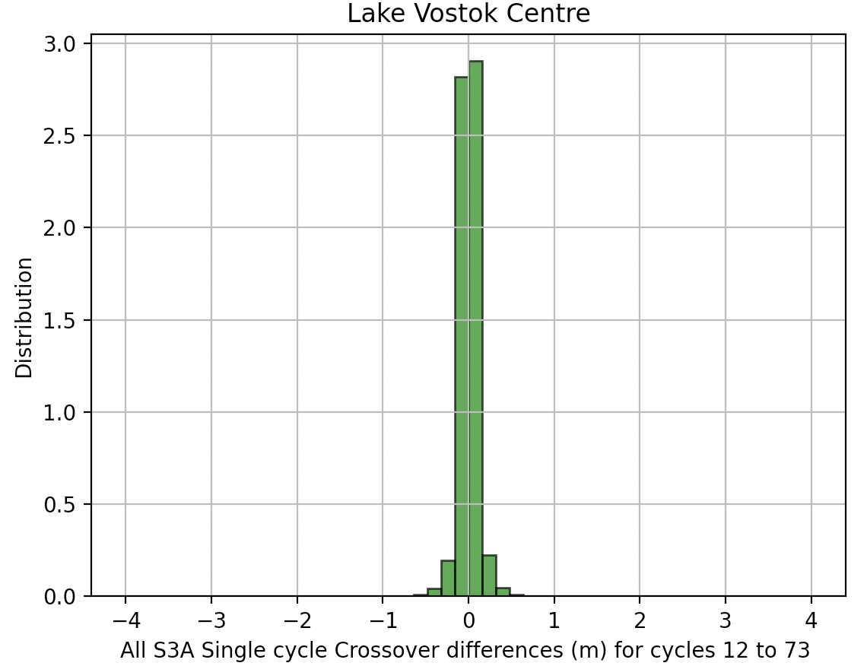
Figure 9: Histogram of all S3A Mission Elevation Differences at Crossover Locations over Lake Vostok

Validation of Measurement Accuracy

To conduct an independent evaluation of the accuracy of our Sentinel-3A ice sheet elevation measurements, we used elevation data acquired by the Airborne Topographic Mapper (ATM), which provides surface elevation measurements with an along-track sampling every 0.25 s (equating to a ∼30 m interval for a typical aircraft velocity) and an 80 m across-track platelet at nadir. The Level-2 product was chosen because the processing includes a smoothing of the Level-1b data, which reduces the impact of uncorrelated shot-to-shot noise on our validation dataset and also brings the measurement cell closer to the resolution of the SAR footprint. The ATM measurements have been estimated to have a vertical accuracy and precision of 7 and 3 cm, respectively (Martin et al., 2012, [R2]).

Whilst ATM flight campaigns have been carried out over both Antarctica and Greenland during the Sentinel-3 mission period, Antarctic ATM measurements have been made predominantly over the marginal regions due to the difficulty of operating flights over the remote interior. Therefore, in order to measure S3 accuracy, we select an area of north west Greenland with good ATM coverage and a representative range of surface slope (0 to 0.6º) from smooth flat ice in the ice sheet centre to increasingly sloping terrain towards the margins (figure 10).
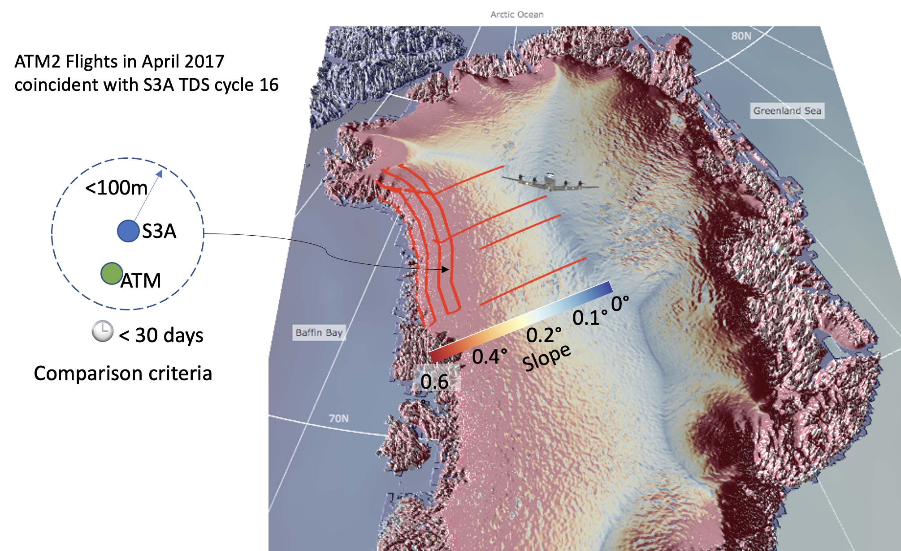
Figure 10: Operation IceBridge ATM flights used for validation of S3A measurements, overlayed on a slope map of north Greenland.
The results of the comparison between S3A elevation (OCOG) and ATM elevations are shown below for increasing bands of slope:

Comparison: ATM elevation-S3A elevation_ocog_20_ku
Slope Band | Mean Diff (m) | Median Diff (m) | Median Absolute  Diff (m) | Standard Deviation of Diffs (m) | Number of Comparisons
0.0 to 0.1º | -0.01 | -0.03 | 0.06 | 0.10 | 21
0.1 to 0.2º | -0.19 | -0.07 | 0.25 | 0.77 | 80
0.2 to 0.4º | -0.57 | -0.49 | 0.71 | 1.57 | 139
0.4 to 0.6º | -2.81 | -1.77 | 2.86 | 5.61 | 165

Note that there was a small improvement in S3 performance in IPF 6.18 due to the introduction of a new slope model. As there has not been a full mission reprocessing since then, cycles containing this evolution (> cycle 54, Jan 2020) do not coincide with Operation Icebridge campaigns (2009-2019) and therefore cannot yet be directly validated using this method.

Known Issues over Land Ice

Issue | Products Affected
The processing of SAR Ku-band echoes at Level-1 is not optimized for land ice resulting in waveforms not being centered in the range window (from an initial extended window). This can result in waveform truncation and lost echoes over areas of higher slope such as the ice sheet margins, causing lower than expected measurement density and accuracy over these regions. This issue is corrected in the future Thematic land ice product (scheduled for release in 2022). | All ESA L2 land products up to an including PB2.68 (IPF 6.19).
S3A operated in open loop tracking command (OLTC) mode during its commissioning phase (cycles 1-11). It was found that the OLTC mode (which uses an on-board DEM) was not able to accurately track the surface over the ice sheet margins, resulting in very high failure rates. S3A was switched to autonomous closed loop tracking from cycle 12 onwards, which greatly improved the measurement density. | All ESA L2 land products up to an including PB2.68 (IPF 6.19), S3A cycles 1-11 only. S3B was not affected.
A mean bias of -18dB was applied to Ku-band sigma0 backscatter parameters from PB 2.61. This results in step in sigma0 when processing the full mission time series. | All ESA L2 land products processed using PB2.61 or later.

References

1 | Brief communication: Ice sheet elevation measurements from the Sentinel-3A and Sentinel-3B tandem phase | McMillan.M, Muir.A, Donlon.C, Cryosphere, Jul 2021
2 | Airborne Topographic Mapper Calibration Procedures and Accuracy Assessment, NASA Technical Report NASA/TM/u20132012-215891, Goddard Space Flight Center, Greenbelt, Maryland 20771, available at: https://ntrs.nasa.gov/archive/nasa/casi.ntrs.nasa.gov/20120008479.pdf | Martin, C. F., Krabill, W. B., Manizade, S. S., Russell, R. L., Sonntag, J. G., Swift, R. N., and Yungel, J. K.
3 | Sentinel-3 Delay-Doppler altimetry over Antarctica | Malcolm McMillan.M, Muir.A, Shepherd.A, Escolà.R, Roca.M, Aublanc.J,Thibaut.P, Restano.M, Ambrozio.A, Benveniste.J, The Cryosphere, 13, 709–722, 2019  https://doi.org/10.5194/tc-13-709-2019

