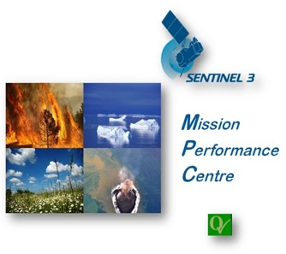

Technical Note on
Sentinel-3
Performance over
Sea Ice

Document Ref.:
Date: | 20/10/2021
Issue: | 1.0
Author(s): | A.Muir (MSSL), D.Brockley (MSSL), S.Baker (MSSL), I.Lawrence (University of Leeds)
Approved by: |  | Authorized by | J. Bruniquel, Service Manager
Distribution: | ESA, S3MPC
Accepted by ESA | P. Féménias, ESA TO
Filename

Copyright ©2019 – CLS, ECMWF, isardSAT, LEGOS, MSSL, NOVELTIS, PML
All rights reserved.
No part of this work may be disclosed to any third party translated, reproduced, copied or disseminated in any form or by any means except as defined in the contract or with the written permission of ACRI-ST

Disclaimer
The work performed in the frame of this contract is carried out with funding by the European Union. The views expressed herein can in no way be taken to reflect the official opinion of either the European Union or the European Space Agency.
 |  | 

Table of Contents
Table of Contents 2
Acronyms 2
Purpose of Document 3
Applicable ESA L2 Product Baseline 3
Primary Measurements over Sea Ice 3
Measurement Availability over Sea Ice 4
Measurement Precision over Sea Ice 7
Validation of Measurement Accuracy 9
Summary 15
Known Issues over Sea Ice 16
References 16

Acronyms

CS2 | CryoSat-2 satellite
ESA | European Space Agency
IPF | Instrument Processing Facility
L1B | Level-1B product or processing. L1B data is the Level-0 (raw) data corrected for instrumental and geometrical effects.
L2 | Level-2 product or processing. L2 is the Level-1 data corrected for geophysical effects.
MYI | Multi-year Ice (sea ice)
NSIDC | National Snow and Ice Data Center (USA)
PB | Product Baseline
S3 | Sentinel-3 missions
S3A, S3B | Sentinel-3A or 3B mission
SAR | Synthetic Aperture Radar
SARin | Synthetic Aperture Radar in Interferometric mode (available on CryoSat-2).
SHA | Surface Height Anomaly (the height of a surface above mean sea level)
SLA | Sea Level Anomaly (the height of a sea surface above mean sea level)
SSMI | Special Sensor Microwave Imager

Purpose of Document

This technical note provides details of the current performance (measurement coverage, precision, uncertainty and accuracy) of Sentinel-3 missions over sea ice surfaces. Previous studies (Lawrence, 2019 [R5], and S3-MPC internal studies) have shown that the performance of Sentinel-3A and Sentinel-3B are equivalent over sea ice, and hence in this document we only show performance metrics from Sentinel-3A unless otherwise specified.

Mission performance is measured from the current ESA Level-2 operational SR_2_LAN products (which includes all sea ice areas) and is not necessarily the final or optimal performance of the S3 missions over sea ice.

Applicable ESA L2 Product Baseline

In this technical note the performance is measured with ESA Level-2 Land products from the following product baseline:

 | S3A | S3B
Product Baseline | 2.68 | 1.43
Baseline Collection | 004

Note that in 2022 a new ESA Thematic Sea Ice L2 product is due for release with significantly improved performance over sea ice. This document does not cover the performance obtained with that product or related test data sets.

Primary Measurements over Sea Ice
The primary S3 Ku-band 20Hz SAR measurement over sea ice is radar freeboard (the height of the radar scattering horizon above the local sea surface, stored as Level-2 product parameter freeboard_20_ku). This may differ from sea ice freeboard (the height of the snow-ice interface above the local sea surface) depending upon the penetration depth of the radar echo. Penetration depth is dependent on local snow and sea ice properties. Radar freeboard has also not been corrected to account for the slower speed of propagation of the radar pulse through the snow layer above the sea ice.
Radar freeboard is calculated from the difference between the surface height anomalies (SHA) over sea ice floes and an interpolated sea surface height anomaly between leads in the sea ice as shown in figure 1.

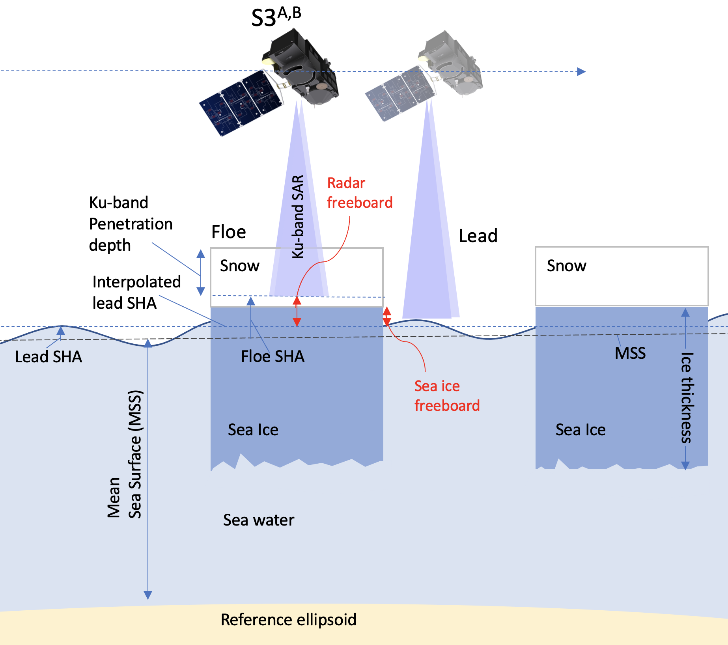
Figure 1: Measurement of Radar Freeboard
Radar freeboard can be converted to a sea ice thickness (a key climate change parameter) when combined with a knowledge or estimate of local snow thickness and the densities of snow, sea ice and sea water. Sea ice thickness is not currently a direct output of ESA L2 products (as it requires external climatology for its calculation) and is therefore not assessed in this document.

Measurement Availability over Sea Ice
This section shows how successful the S3 radar instrument and ground processing is at obtaining freeboard measurements over Arctic and Antarctic sea ice during the polar winter and summer months.

Obtaining radar freeboard measurements along track is only possible when the radar and ground processing is able to successfully discriminate between echoes obtained over sea ice floes and leads (exposed sea between sea ice floes) and obtain sea surface height measurements (after waveform retracking). During the Arctic summer (May-Sept), sea ice extent is reduced and melt ponds form on the sea ice surface, making discrimination between leads and floes very difficult, and hence greatly reducing the number of possible freeboard measurements. In the Antarctic Ocean, sea ice properties and higher snow loading make measurement of freeboard from radar altimeters complex as the sea ice can be pushed below sea surface.

The number of S3A freeboard measurements obtained over the Arctic and Antarctic oceans (and % of possible measurements calculated along track) for each cycle and month are shown in figure 2. As expected, measurement numbers greatly reduce in the summer months in each hemisphere, and there are a greater number of successful measurements obtained in the Arctic than the Antarctic oceans.

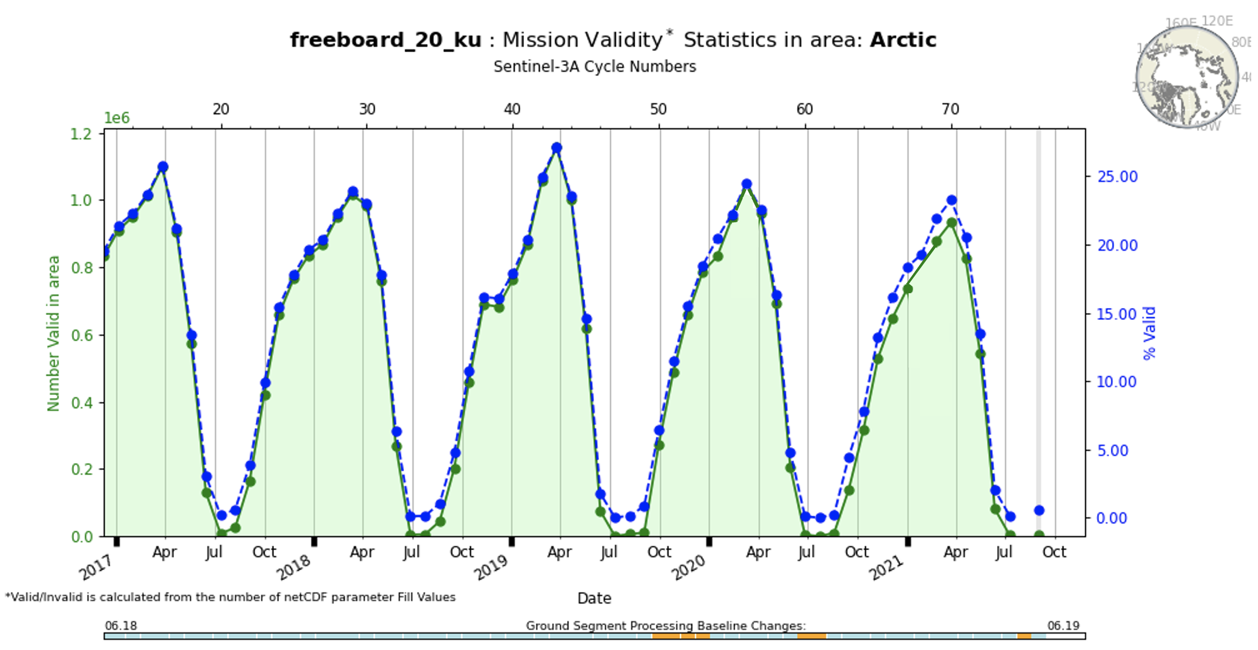

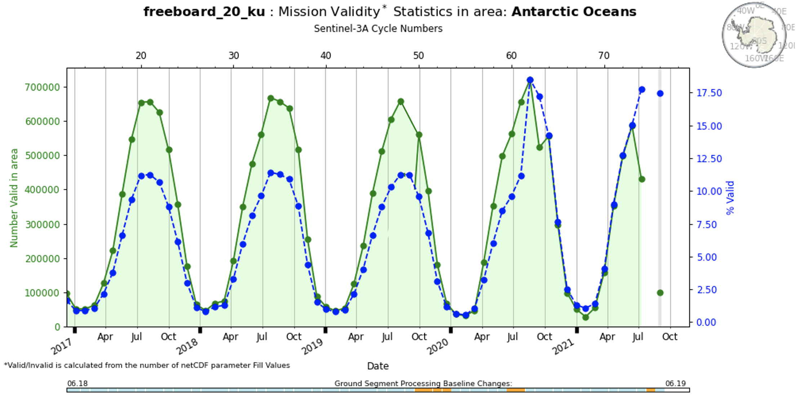
Figure 2: S3A Freeboard measurement availability over the Arctic and Antarctic oceans
The number and seasonal variation of freeboard measurements from S3B follows the same pattern, covering the same areas of sea ice below 81.35N, but with an orbit pattern 140º out of phase with S3A.
The spatial extent of S3A and S3B Arctic freeboard measurements over a typical winter season are shown below in figure 3 alongside a comparison to NSIDC 15% sea ice extent data from SSMI passive microwave. This shows that S3A and S3B freeboard measurement coverage provides a good match to independent extent data (excluding the pole hole).

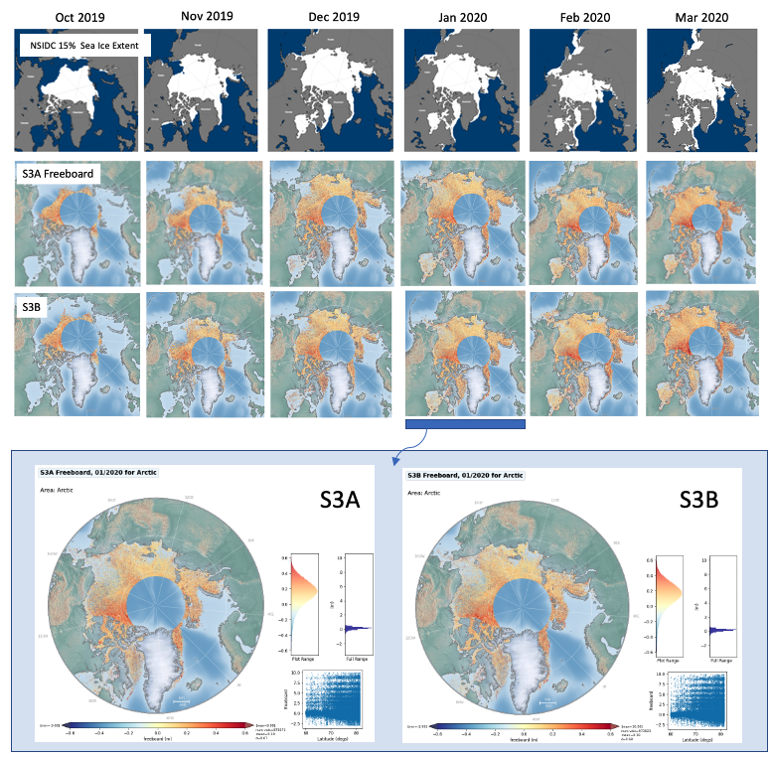
Figure 3:S3A and S3B Freeboard area coverage for Winter (2019/2020), and January 2020 (bottom row), in comparison with NSIDC sea ice extent data.

Typical peak coverage of the Antarctic sea ice (Jun/Jul 2021) is shown for S3A and S3B below (figure 4):
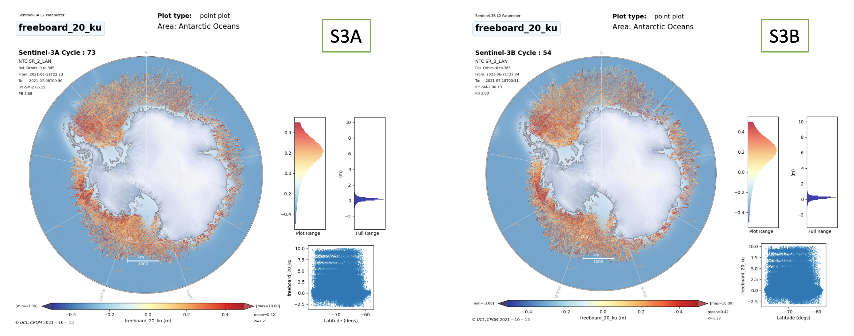
Figure 4:Freeboard coverage from S3A and S3B over the Antarctic Ocean in June/July 2021

Measurement Precision over Sea Ice
In this section we measure how precise the S3 radar instrument and ground processing is at measuring the sea-surface height anomaly over sea ice leads and floes, and compare these results to those obtained from CryoSat-2 (baseline-D products).

In order to measure the maximum achievable precision of sea-surface height anomaly measurements over sea ice floes and leads, we select satellite ground tracks containing multiple consecutive measurements over floes and leads in areas where the SLA profile is relatively flat. We measure the standard deviation of these measurements over each surface type. As per Tilling et al [R1], we select tracks over the Hudson Bay in June/July where there is no MYI cover and rapid ice retreat. Here we have areas of very thin ice which return sequences of low-noise specular echoes (as would be returned by a lead) and areas of open water where low-noise returns are similar to those from ice floes.

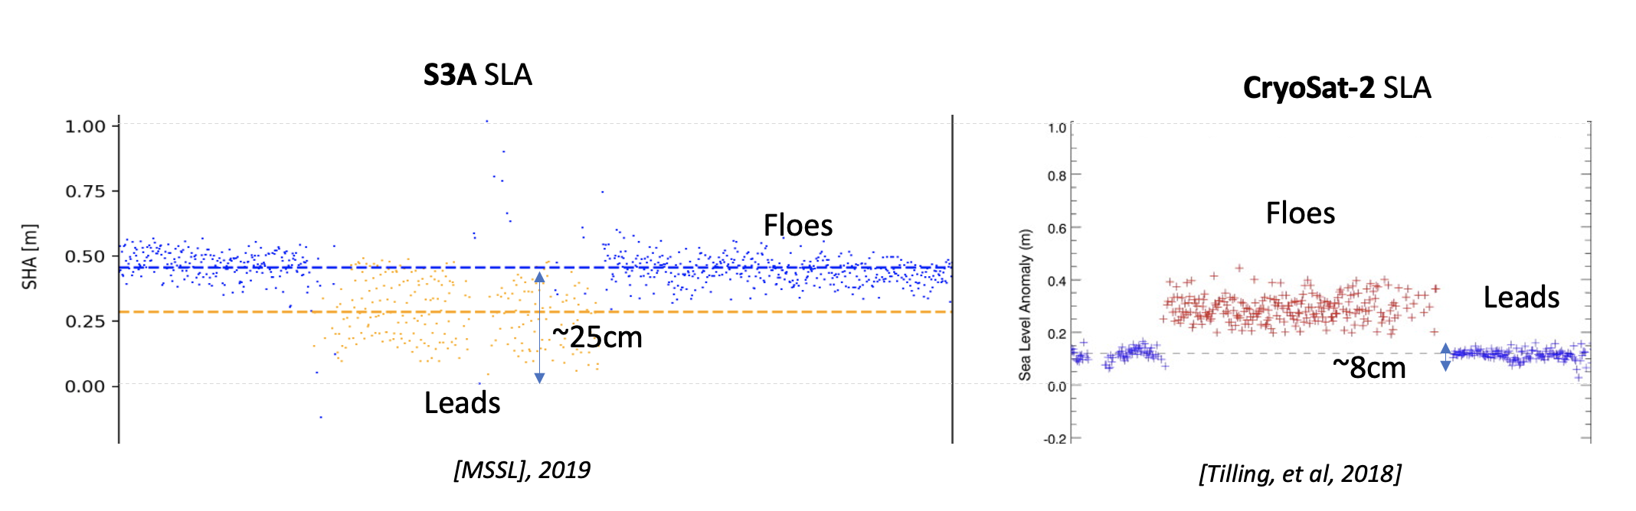
Figure 5: SLA measurements over floes and leads in the Hudson Bay from S3A and CryoSat
Mission | SLA stdev over Leads | SLA stdev over Floes
S3A | 12.5 | 11.4
CryoSat-2 | 4.1 | 9.8

As can be seen by figure 5, the spread of SLA measurements over leads is more than 3 times higher for S3A than for CryoSat-2 (which has a similar Ku-band SAR radar instrument). The reason for the poor performance of S3 is that the lead echoes are under sampled due to the lack of zero-padding in the S3 L1b processing. This issue is being corrected in the S3 thematic sea ice products due for release in 2022.

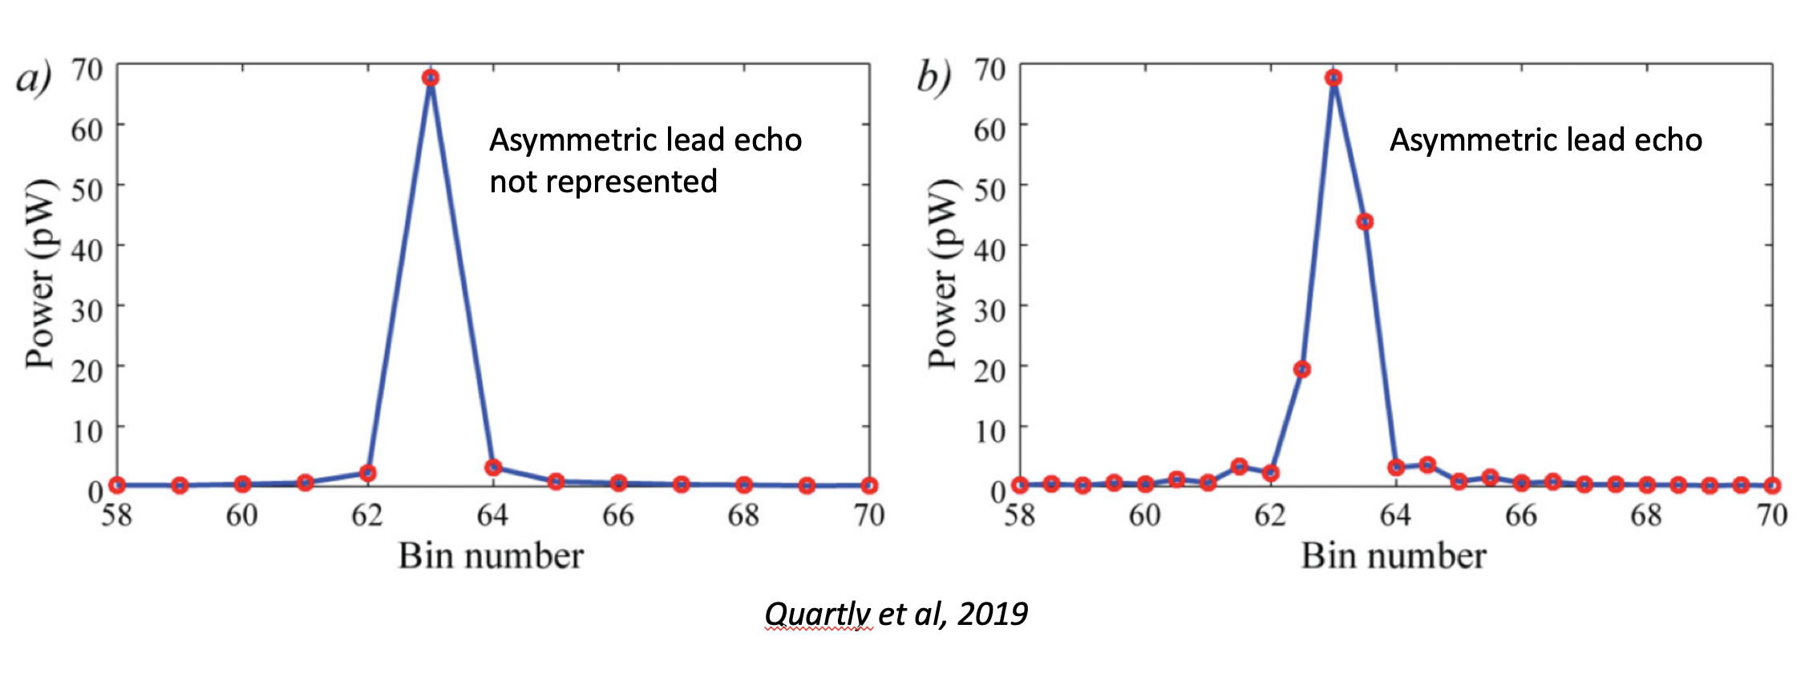
Figure 6: Under sampled specular echo (a), causing poor lead SHA precision, and 2x sampling as used by CryoSat-2 ( Quartly et al, 2019).
An effect of the lack of zero-padding is jitter in the SHA measurements (as shown in figure 7) . These would normally be corrected by the tracker correction.
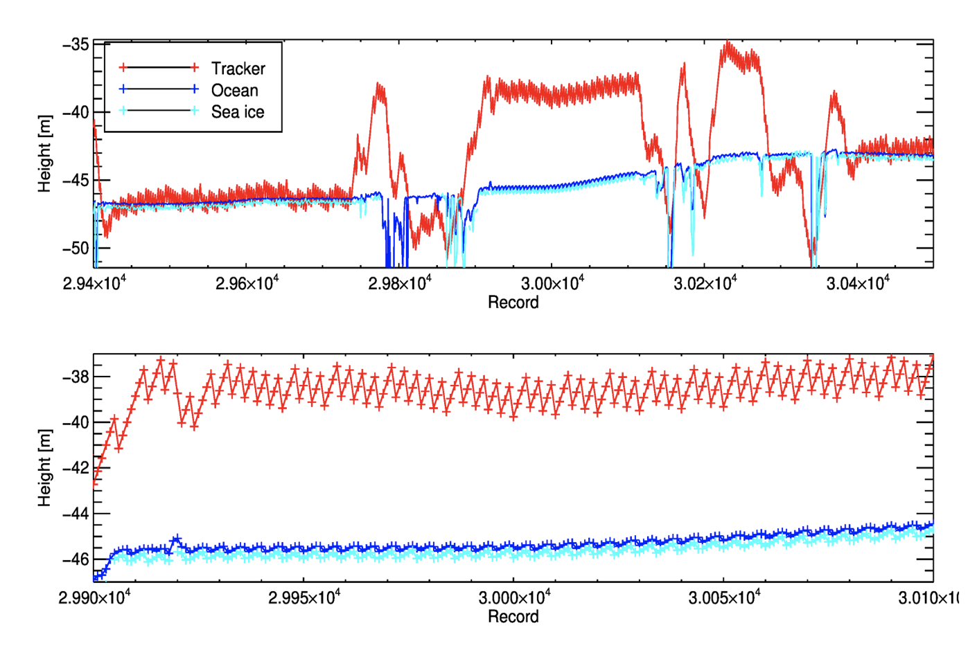
Figure 7: Uncorrected jitter noise in S3 SHA measurements (MSSL study).

Validation of Measurement Accuracy

In order to measure the accuracy of S3 freeboard measurements over the whole Arctic we can compare with external Ku-band 20Hz freeboard data from CryoSat-2. CryoSat-2 has operated since 2010, and its freeboard measurements have been validated by multiple field campaigns and validation experiments (CryoVex, Operation IceBridge, etc).
CryoSat-2 operates a near identical Ku-band SAR radar mode over the majority of the Arctic, and SARin mode over some coastal areas. It therefore measures the same ice surface (radar freeboard) as the S3 missions and although the orbit is different, we would expect similar mean results when freeboard measurements are gridded at 25km. Any differences can indicate an issue with S3’s radar instrument or ground processing.

To test the differences between S3A and CryoSat-2’s radar freeboard measurements we take a sample winter month (March 2017) and grid both missions at 25km resolution, excluding any CryoSat-2 measurements at higher latitudes than the S3 orbit’s maximum latitude (81.35N).

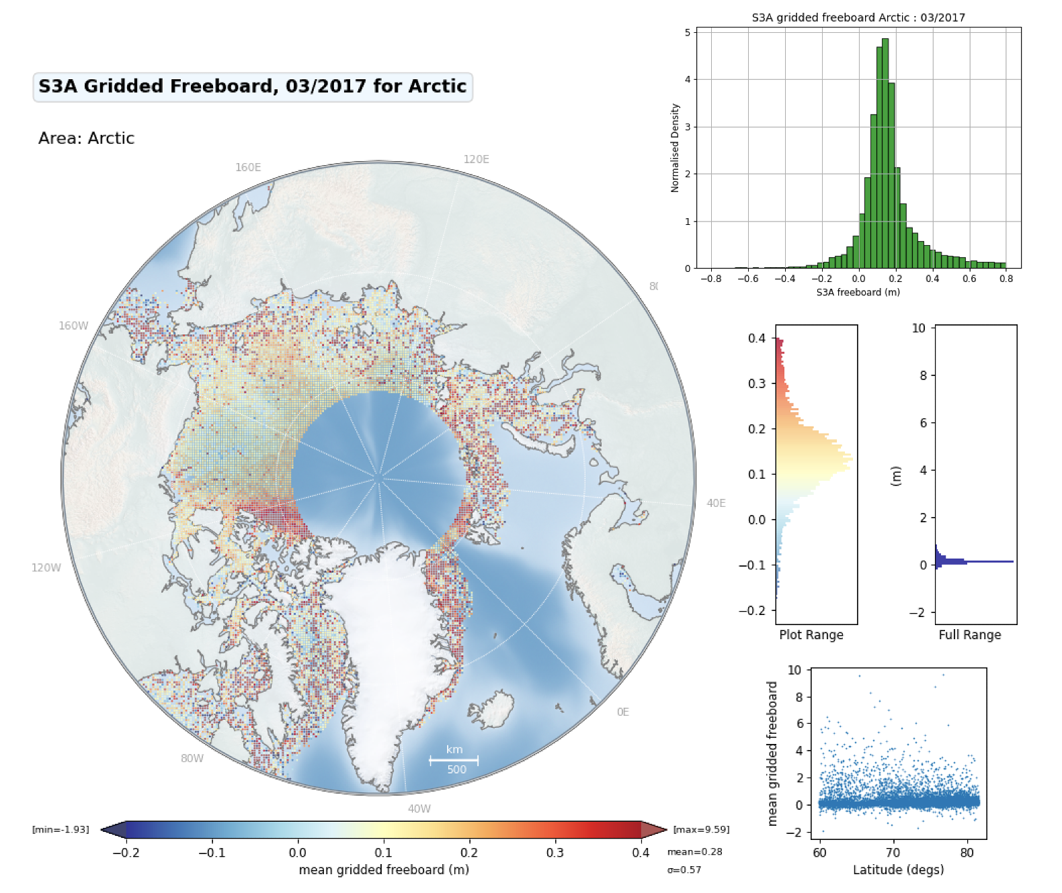
Figure 8: S3A mean freeboard in a 25km grid for March 2017

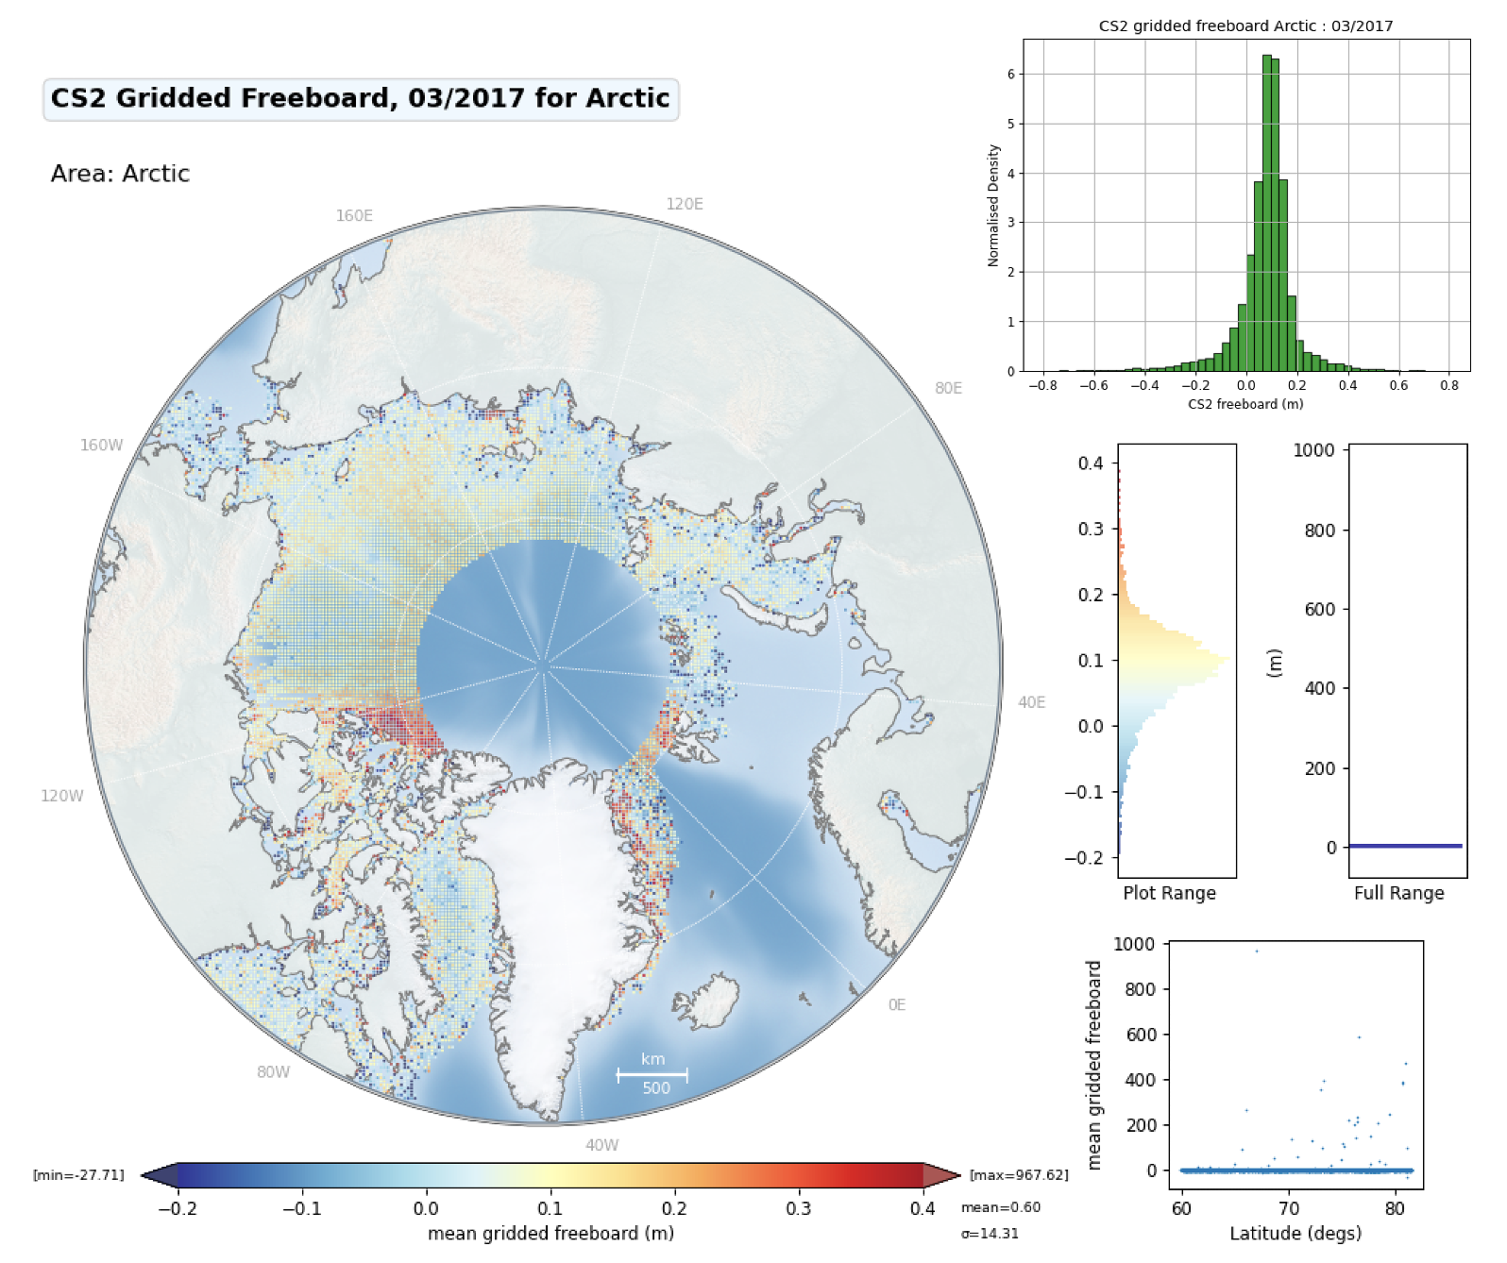
Figure 9: CryoSat-2 mean freeboard in a 25km grid for March 2017
From the freeboard maps (figures 8 & 9), we can see that S3A freeboard has more noise than CryoSat-2’s freeboard, and by plotting the two histograms together (figure 10) we can see a clear bias between the two, and that S3A has a higher distribution of large positive values.
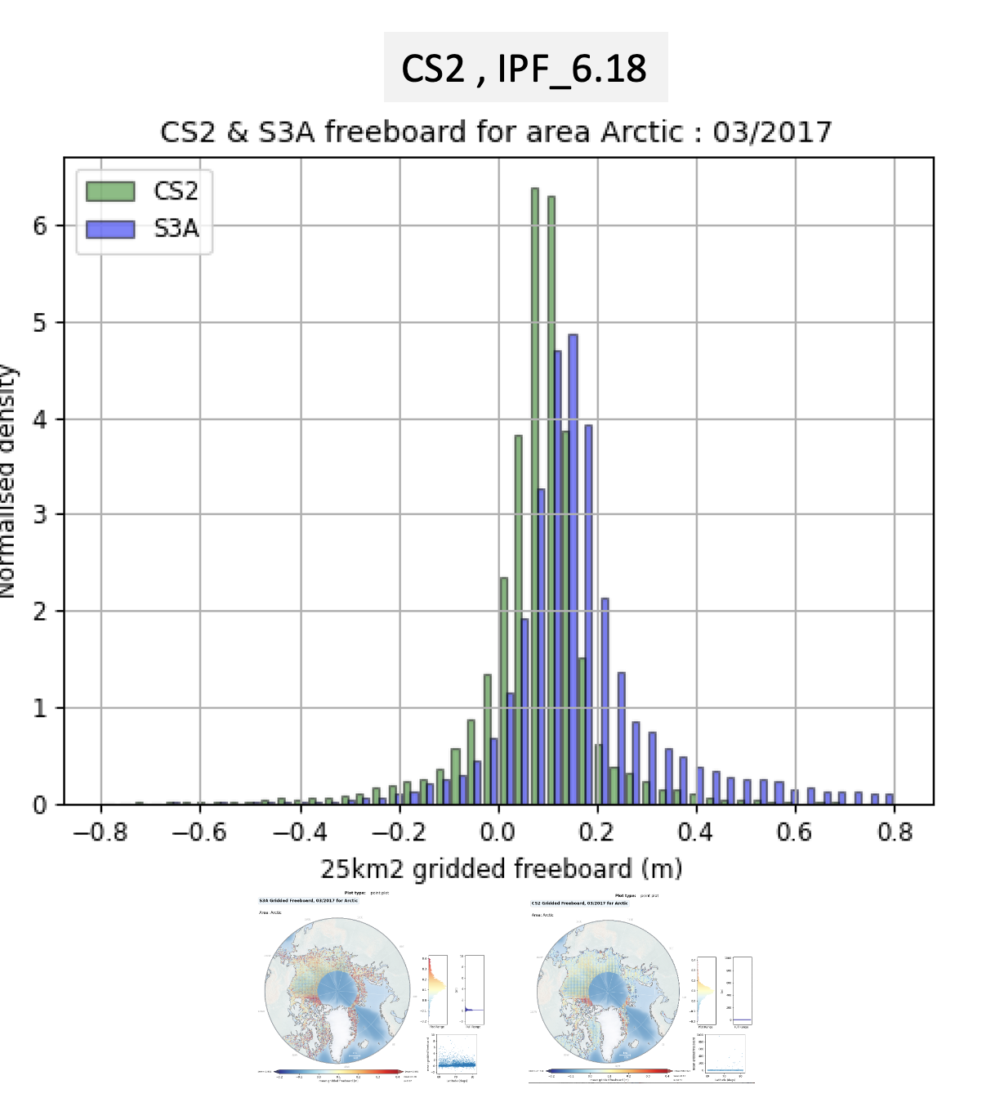
Figure 10: Histograms of S3A and CS2 Arctic Mean Gridded Freeboard

The difference map between S3A and CS2 mean freeboard can be calculated as shown in figure 11.

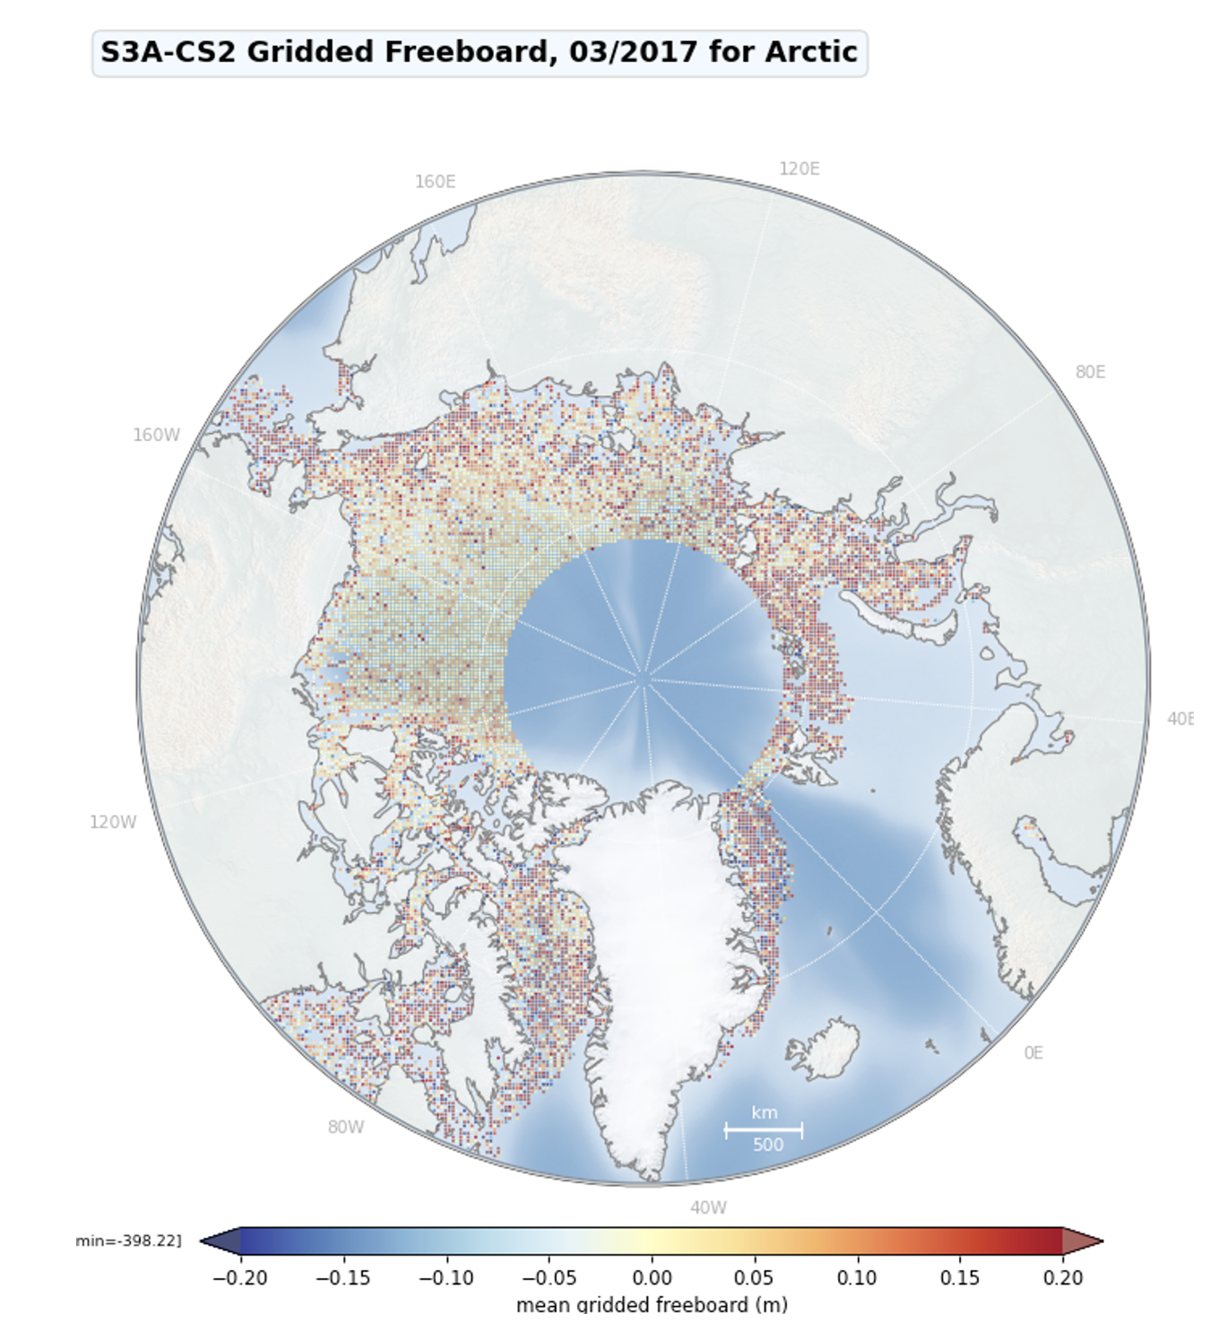
Figure 11: S3A – CS2 mean gridded freeboard difference

The histogram of differences shows the positive bias (6.2cm mean) and high positive differences (12.8cm stdev).

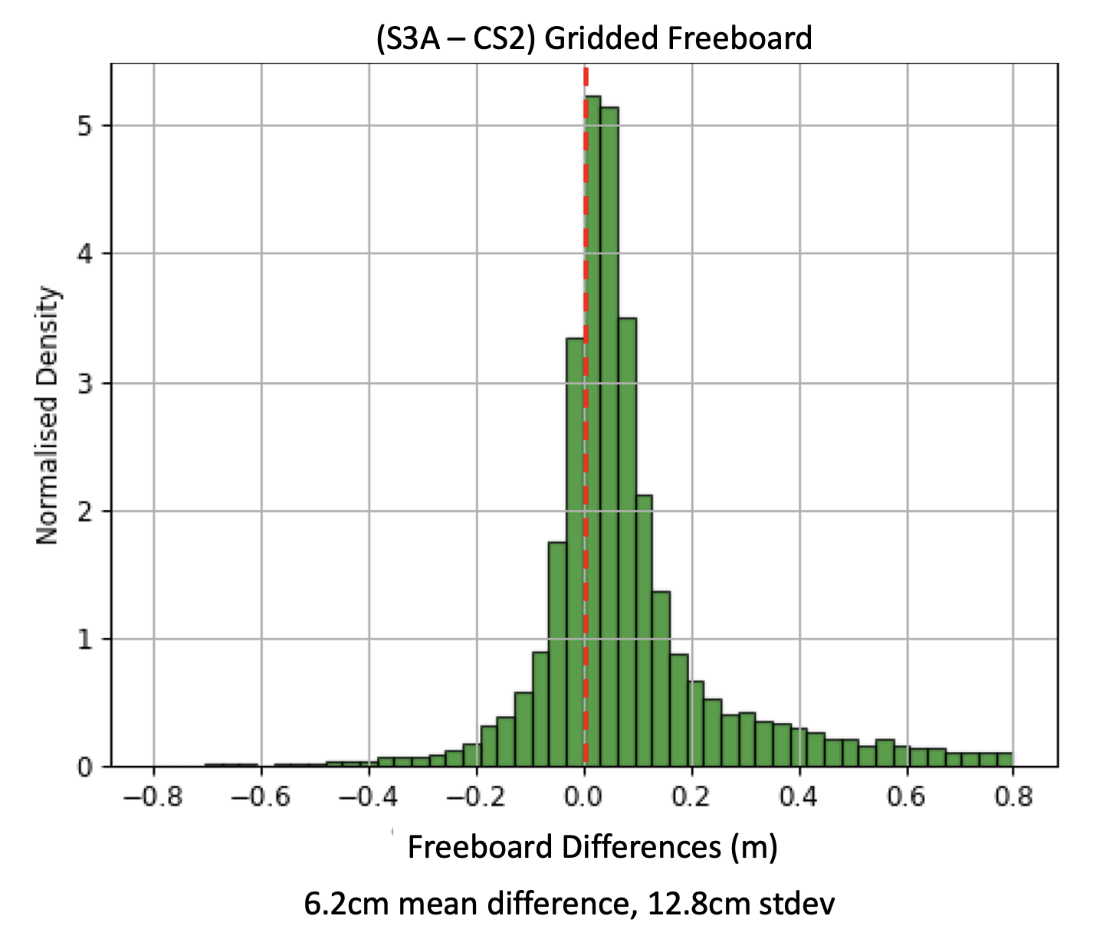
Figure 12: Histogram of Differences between S3A and CS2 Gridded Freeboard (Mar 2017)

The differences shown between CS2 and S3A freeboard can be explained by the lack of zero-padding and hamming weighting in the S3 L1b processing [R4]. This issue is being corrected in the S3 thematic sea ice products due for release in 2022.

Uncertainty of Monthly Freeboard

A standard measure of Arctic freeboard from radar altimetry is to provide gridded monthly means, typically at a 25km grid resolution. We can estimate the uncertainty (figure 13) of the monthly S3A freeboard in each grid cell from the standard deviation of contributing measurements and compare these with comparable missions such as CryoSat-2 (figure 14) for the same period. Before calculating the standard deviation we perform a 3-sigma clip to ensure that extreme outliers resulting from poor retracking or noise spikes do not bias the grid-average estimates.

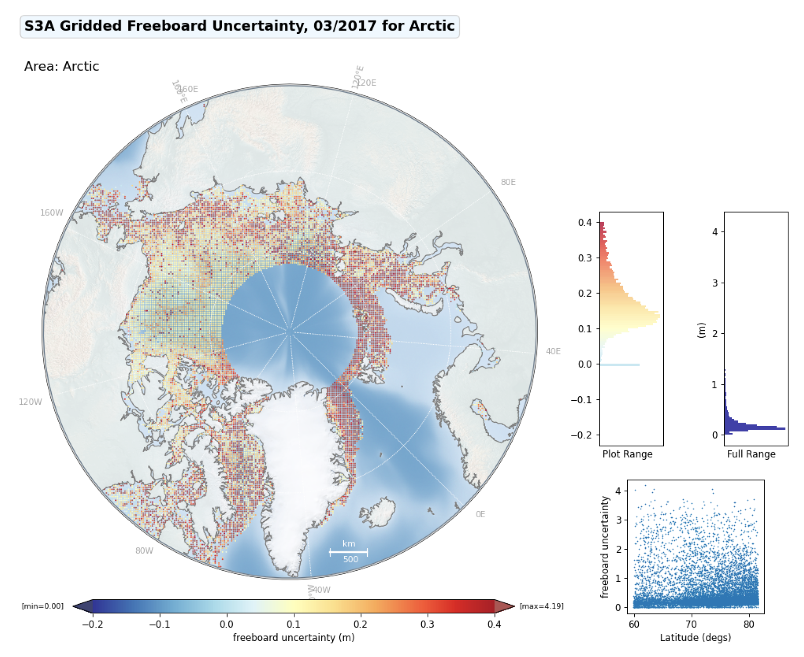
Figure 13: Uncertainty of S3A Gridded Freeboard (March 2017)
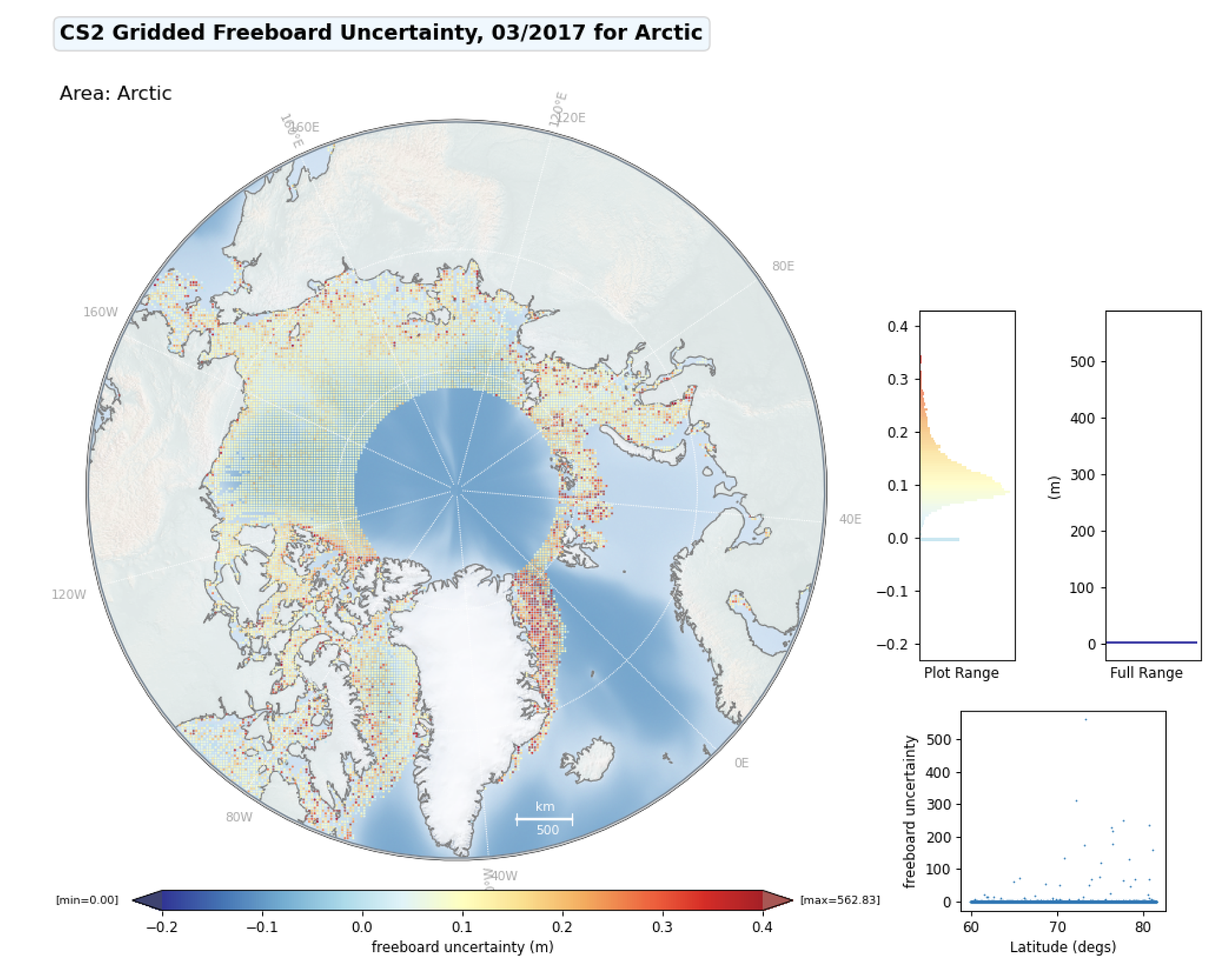
Figure 14: Uncertainty of CS2 Gridded Freeboard (March 2017)
As can be seen, the uncertainty increases towards the coastline in both missions. This is expected as unresolved tidal variability and small-scale ocean dynamics in shallow shelf areas may adversely affect the local sea level interpolation and the ability to resolve leads in the sea ice reduces with land-fast ice towards the coast [R3]. However, the magnitude and spread of uncertainty is much greater in S3 as compared to CS2, even away from the coastlines. This can be explained by known issues [1,2] below.

Summary

- Seasonal freeboard area coverage and measurement numbers are as expected in comparison to NSDIC sea ice extent data and given known issues with measuring freeboard from all radar altimetry missions during summer months when melt ponds form on the sea ice.
- Precision of SHA measurements over leads is 3x lower than expected in comparison to CryoSat-2.
- Validation of accuracy shows significant differences (6.2cm mean difference, 12.8cm stdev) between gridded mean freeboard from S3A and CryoSat-2.
- Lower than expected precision and accuracy of S3A and S3B freeboard is known to be a result of missing steps specifically required for sea ice (Hamming weighting and zero padding, [R4]) in the ocean optimized L1b processing used for the current product baseline.
- Thematic sea ice products (due in 2022) have significantly better performance due to optimised L1b processing.

Known Issues over Sea Ice

 | Issue | Products Affected
1 | The processing of S3 SAR Ku-band echoes at Level-1b is not optimized for sea ice and lacks the required zero-padding step [R4]. Zero-padding (ZP) up-samples the received signal by a factor of two.  Lack of ZP can result in under-sampling of specular echoes and a lack of precision and accuracy in lead SHA. | All ESA L2 land products up to an including PB2.68 (IPF 6.19). This issue is corrected in the future Thematic sea ice product (scheduled for release in 2022).
2 | The processing of S3 SAR Ku-band echoes at Level-1b is not optimized for sea ice and lacks the required hamming weighting [R4] step. Hamming weighting dampens the contribution from high off-nadir beams to mitigate the effect of side-lobe ambiguities.  This can result in contamination of waveforms over floes with off-nadir leads. | All ESA L2 land products up to an including PB2.68 (IPF 6.19). This issue is corrected in the future Thematic sea ice product (scheduled for release in 2022).

References

1 | Retrieving Sea Level and Freeboard in the Arctic: A Review of Current Radar Altimetry Methodologies and Future Perspectives | Quartly, G.D.; Rinne, E.; Passaro, M.; Andersen, O.B.; Dinardo, S.; Fleury, S.; Guillot, A.; Hendricks, S.; Kurekin, A.A.; Müller, F.L.; Ricker, R.; Skourup, H.; Tsamados, M. Remote Sens. 2019, 11, 881. https://doi.org/10.3390/rs11070881
2 | Estimating Arctic sea ice thickness and volume using CryoSat-2 radar altimeter data. | Tilling, R.L.; Ridout, A.; Shepherd, A., Adv. Space Res. 2018, 62, 1203–1225.
3 | Extending the Arctic Sea Ice Freeboard and Sea Level Record with the Sentinel-3 Radar Altimeters | Lawrence,I.R;Armitage,T.W.K; Tsamados,M.C; Stroeve.J.C; Dinardo.S; Ridout.A.L; Muir.A.S; Shepherd.A., Adv. Space Res. 2021, 68, 711–723.
4 | Guidelines for the SAR (Delay-Doppler) L1b Processing. | Dinardo, S., Benveniste, J., 2013., Technical Report Issue 2.3, 29/05/2013. ESA Esrin. Frascati, Italy.
5 | Multi-satellite Synergies for Polar Ocean Altimetry | Lawrence,I, Doctoral thesis (Ph.D), UCL (University College London), https://discovery.ucl.ac.uk/id/eprint/10087932

